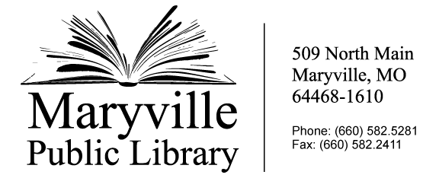
Maryville Public Library Volunteer Board Application
Name: _________________________________________________
Address: _______________________________________________
Phone:_________________________________________________
Email:__________________________________________________
Place of employment if applicable: _______________________________________________________

Please answer the following:
The MPL Board of Trustees currently meets the second Tuesday of every month at noon at the library. Are you available and willing to commit to attending those meetings?

Board meeting packet materials are typically delivered to board members through email. Do you have access to an email account, and if not, are you willing and able to use the library’s public use computers to stay informed of library board business?

To stay compliant with Missouri State law, each of the nine members of the MPL Executive Board are required to take turns either presiding over monthly meetings, taking meeting minutes, or making themselves available to sign checks or contracts. Are you willing to accept responsibility for these tasks when the need arises?

Before answering the next questions, please review the MPL’s current mission, goals, and operating budget under the “About Us” page of the library’s website at www.maryvillepubliclibrary.lib.mo.us (Print copies are also available at the library’s front desk.)

Do you have any ideas that could generate improvement or progress in the library’s efforts to pursue its mission and goals? Please review the library’s operating budget and include ideas about how to fund those measures.

Library Board Members approve the library’s annual operating budget, ensure the library is adequately funded for operations, including the maintenance of its building and grounds. Please list any relevant knowledge or personal experience you could bring as a contribution to this governing board.

Do you have any potential conflicts of interest serving on this board?

NOTE: All Missouri public library districts are governed by library boards or as otherwise provided by law. Board members observe their full legal responsibilities, duties, and rights by holding regular meetings, employing legal and other counsel as necessary, and attending board meetings regularly. The board has complete authority, within legal limits, over the library district’s budget and policies. The board follows statutory requirements as to fiscal year, audit, annual and other reports, and the budgeting process. The library board also appoints the library director who acts as technical advisor to the board, enforces library policies and is responsible for all day-to-day management of the library district (Missouri Public Library Standards, 2012). Laws related to the governance of public libraries in Missouri can be found under Chapter 182 of the Revised Statutes of Missouri.
Please return this application to the Maryville Library Director at 509 North Main Street, Maryville, MO. Applications can also be emailed to director@maryvillepubliclibrary.org .

